**Bike Renting Project**

Madhurima Biswas

7 February 2019

Contents

I. Introduction 3

1.1 Problem Statement 3

1.2 Data 3

II. Methodology 5

2.1 Exploratory Data Analysis 5

2.1.1 Univariate Analysis 8

2.1.2 Bivariate Analysis 12

2.1.3 Data Consolidation 16

2.1.4 Missing Value Analysis 16

2.1.5 Outlier Analysis 16

2.1.6 Feature Selection 19

2.1.7 Feature Scaling 22

2.1.8 Data Sampling 22

2.2 Modeling 23

2.2.1 Model Development 23

2.2.2 Decision tree Algorithm 23

2.2.3 Random Forest Algorithm 26

2.2.4 Multiple Linear Regression 26

2.2.5 KNN Algorithm 29

III. Conclusion 30

3.1 Model Evaluation 30

3.2 Final Model Selection 31

Appendix A - Extra Figures 32

Appendix B - R Code 35

Appendix C - Python code 44

References 50

I. Introduction:

1.1. Problem Statement

Bike rental systems are a flexible transport service where users can rent a two-wheeler vehicle without going through the hassle of buying or maintaining one’s own bike. We are provided daily rental data spanning two years 2011-2012. The objective of this case is to Predication of bike rental count on daily based on the environmental and seasonal settings, so that it helps in better management of the bike rental systems to organize & update their bikes for customers.

1.2. Data

The task is to build ‘predictive regression’ models, which will predict the bike rental count, based on the various factors given in the data during the year 2011-2012.

Given below is a sample of the data set that we are using to predict the rental count:

Table 1.1: Bike Renting sample data (year 2011-12)

|  |  |  |  |  |  |  |  |  |
| --- | --- | --- | --- | --- | --- | --- | --- | --- |
| instant | dteday | season | yr | mnth | holiday | weekday | workingday | weathersit |
| 1 | 01-01-11 | 1 | 0 | 1 | 0 | 6 | 0 | 2 |
| 2 | 02-01-11 | 1 | 0 | 1 | 0 | 0 | 0 | 2 |
| 3 | 03-01-11 | 1 | 0 | 1 | 0 | 1 | 1 | 1 |
| 4 | 04-01-11 | 1 | 0 | 1 | 0 | 2 | 1 | 1 |
| 5 | 05-01-11 | 1 | 0 | 1 | 0 | 3 | 1 | 1 |
| 6 | 06-01-11 | 1 | 0 | 1 | 0 | 4 | 1 | 1 |

|  |  |  |  |  |  |  |
| --- | --- | --- | --- | --- | --- | --- |
| temp | atemp | hum | windspeed | casual | registered | cnt |
| 0.344167 | 0.363625 | 0.805833 | 0.160446 | 331 | 654 | 985 |
| 0.363478 | 0.353739 | 0.696087 | 0.248539 | 131 | 670 | 801 |
| 0.196364 | 0.189405 | 0.437273 | 0.248309 | 120 | 1229 | 1349 |
| 0.2 | 0.212122 | 0.590435 | 0.160296 | 108 | 1454 | 1562 |
| 0.226957 | 0.22927 | 0.436957 | 0.1869 | 82 | 1518 | 1600 |
| 0.204348 | 0.233209 | 0.518261 | 0.0895652 | 88 | 1518 | 1606 |

In the table above, we have the following 15 independent variables, using which we have to predict the Bike Rental Count:

Table 1.2: Predictor Variables

No. Independent Variables

1 instant

2 dteday

3 season

4 yr

5 mnth

6 holiday

7 weekday

8 workingday

9 weathersit

10 temp

11 atemp

12 hum

13 windspeed

14 casual

15 registered

We have in total 7 categorical variables, 8 numeric variables & one Date type variable.

II. Methodology

2.1. Exploratory Data Analysis:

The objective first is to study each feature available in the data and try to assess some patterns and understand the dimensions & properties of the data by exploring it visually. It helps us in understanding the nature of data in terms of distribution of the individual variables/features, finding missing values, relationship with other variables and many other things.

2.1.1. Univariate Analysis:

A. Dependent Target Variable: “cnt”

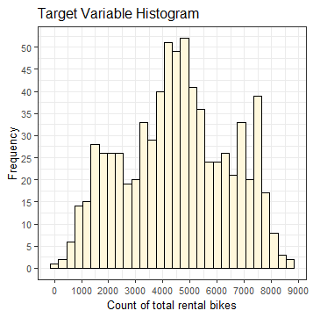

Since our target variable is continuous, we can visualize it by plotting its histogram.

Observation:

* The curve of the frequency distribution of “cnt” variable seems close to normal distribution curve, having mean = 4504 & median = 4548.
* Removing outliers might help reduce the slight skewness in data.
* Range: [22, 8714]

B. Independent Numeric Variables:

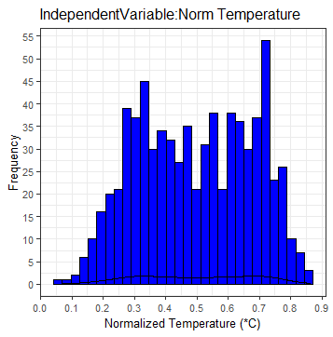 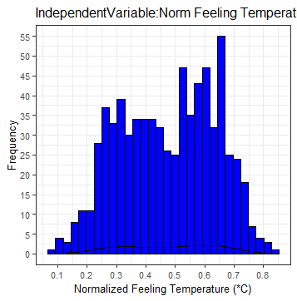

Fig.2.2

Observation:

* We see a wide range of temperature during years 2011-12; however, there is no clear-cut pattern.
* “Humidity” has a mean of 0.62 and “Windspeed” has a mean of 0.19 in 2011-12.

Mostly are within a smaller range and the curve is slight skewed for both.

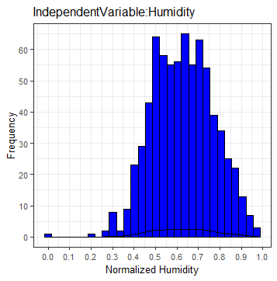 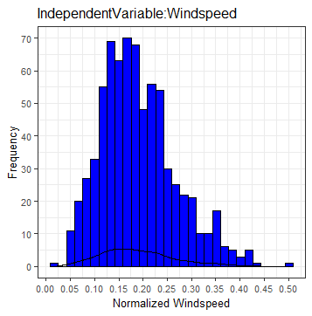

Fig.2.3

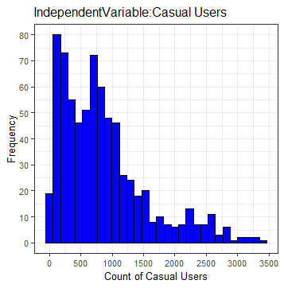 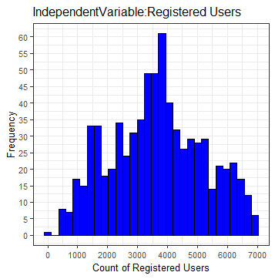

* We observe that most “Casual” per day are lesser in number and it is positively skewed frequency curve. “Registered” users per day have a mean of 3656 over 2011-12.

C. Independent Categorical Variables:

Bar graphs for the categorical variables in the data as follows:

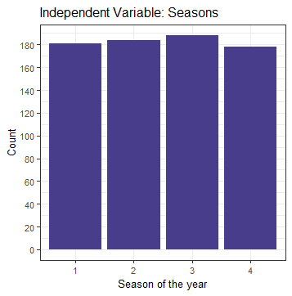 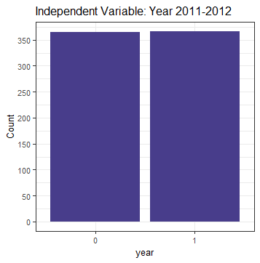

* We observe that “fall” season was compartively longer and “winter” was shortest in the years 2011-12.
* The data is well distributed within year 2011 & 2012 and we can hope to get less error due to data imbalance yearly.

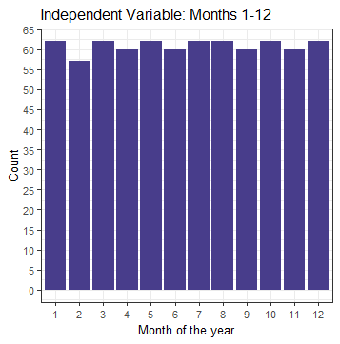 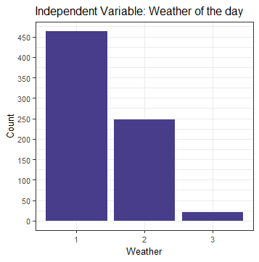

* “Mnth” variable has correct data as February has least days and others have 30/31 days. The weather in 2011-12 was mostly clear or few clouds or partly cloudy.
* “week days” seem properly distributed and obviously there are more working days than holidays and weekends.

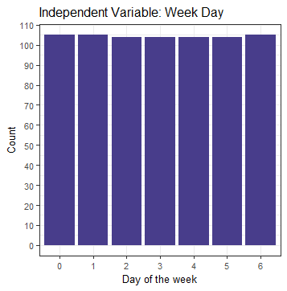 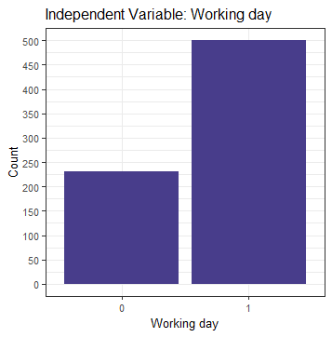

2.1.2. Bivariate Analysis:

After looking features individually, let’s explore the independent variables with respect to the target variable using scatter plots to discover hidden relationships between the independent variable and the target variable and use those findings in missing data imputation and feature engineering.

A. Dependent target Variable Vs Independent Variables:

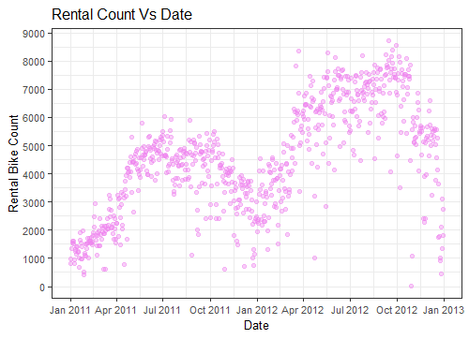

* We observe there are more bikes rented during the year 2012; it maybe because of the increase in popularity of the rental system after a successful year.
* There is no clear-cut pattern for temperature & rental count (comparatively colder country).

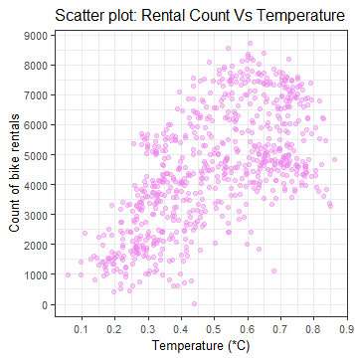 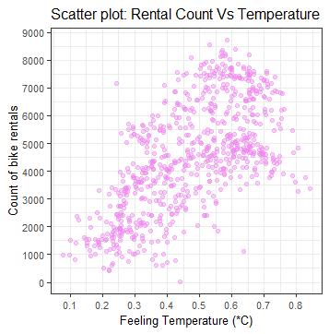

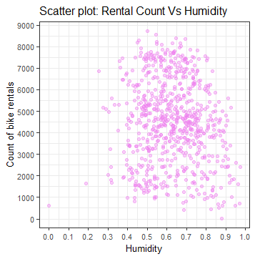 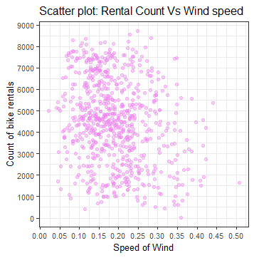

* No such clear-cut patten for humidity or Wind speed & rental count.
* We see a slight linear relationship between Casual users & rental count and a strong linear relationship between Registered users & rental count, which is kind of obvious as rental count is the sum of total users, i.e. casual as well as registered customers.

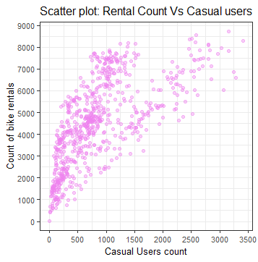 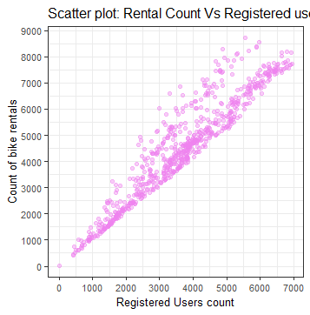

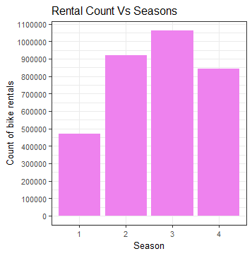 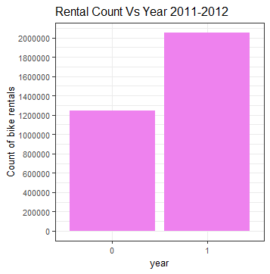

* Rental count is most in fall season and that is expected as fall season was longest in 2011-12. However, the rental count is quite low in spring season which maybe due to low temperature during the season and there maybe seasonal influences on this.
* More bikes were rented in 2012 than in 2011, which could be due to the increase in popularity of bike rental systems.
* Most bikes rented in the month of June, July, August & September.

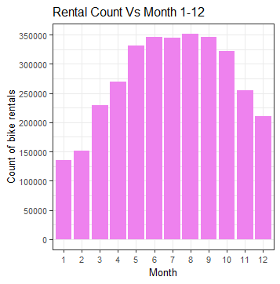 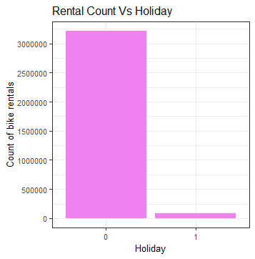

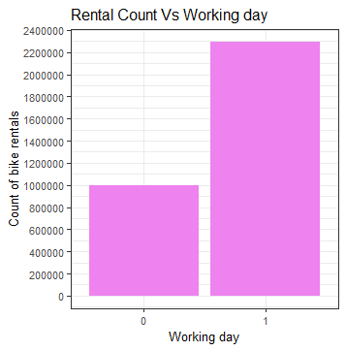 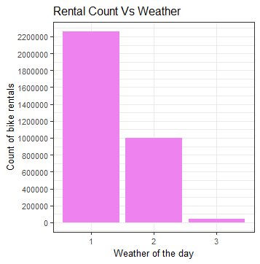

* Bikes are more rented on working days, but that is also because there are more working days in a year.
* More bikes rented on days with clear to partly cloudy weather, but that is also most days in a year.

B. Independent Variable Vs Independent Variable (Interdependencies):

Let’s explore the independent variables with respect to other independent variables using scatter plots to discover hidden relations or dependencies between them.

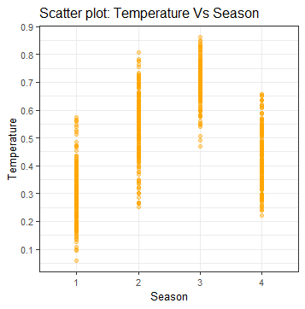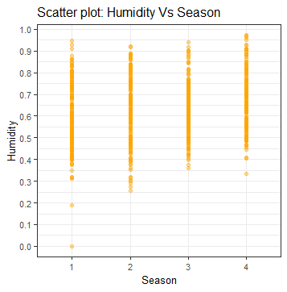

* We observe that temperature is highest in fall season and lowest in winter season.
* We don’t see any dependence of humidity with seasonal changes.

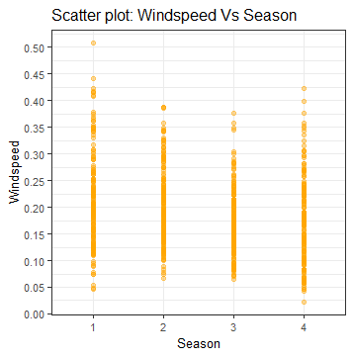 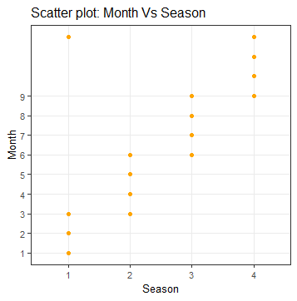

* No such clear-cut pattern of windspeed due to seasonal changes.
* December, March, June & September are the months of seasonal transition.
* There are no days in the data where it was a holiday and a working day both simultaneously, as expected.
* During clear to partly cloudy days, the temperature has a wide range.

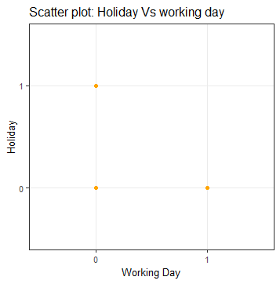 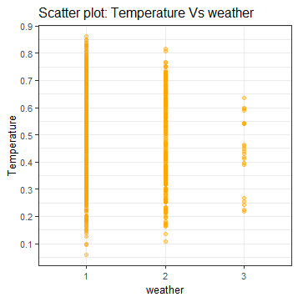

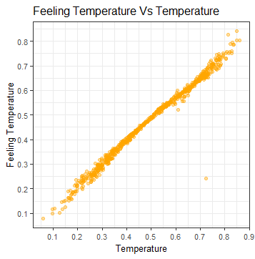 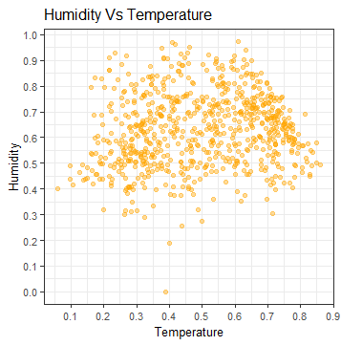

* There is a strong linear relationship between temperature & feeling temperature, as expected.
* No clear-cut pattern of humidity with temperature, except there were less dry air days in 2011-12.
* No clear-cut pattern of wind speed with temperature.
* There is a faint linear relationship between casual users & registered users, but not solid enough to be claimed.

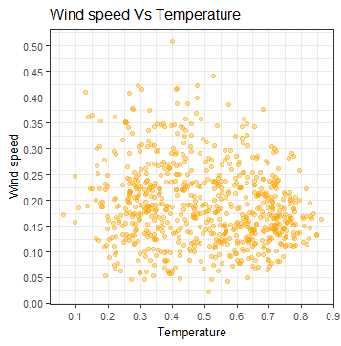 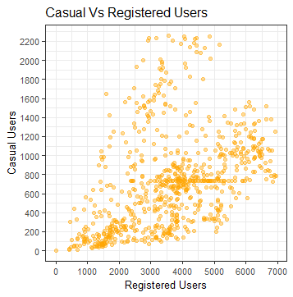

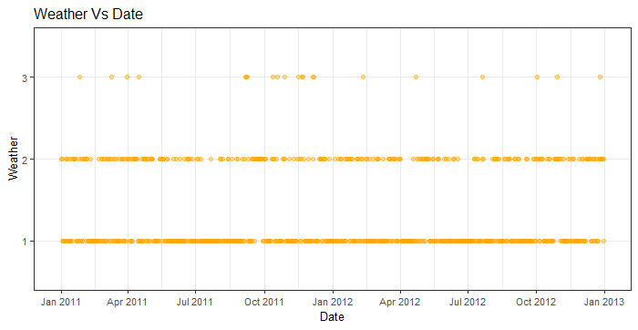

* Most of the year, we observed weather to be clear to partly cloudy in 2011-12.

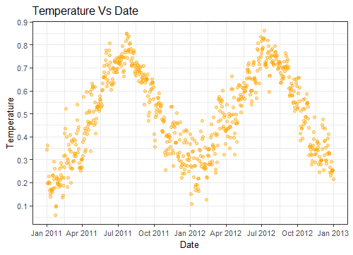

* We observe a similar pattern of temperature in year 2011 & 2012, which tells us that the temperature changes were similar in both the year in changing seasons.

2.1.3. Data Consolidation:

Since not all data are in their proper data types, we need to convert it first to proceed further.

*#_____Data type conversion_____#*

*catnames = c("season","yr","mnth","holiday","weekday","workingday","weathersit") #categorical variables*

*for (i in catnames) {*

*data[,i] = as.factor(data[,i])*

*}*

*numnames = c("temp","atemp","hum","windspeed","casual","registered","cnt") #numerical variables*

*for (i in numnames) {*

*data[,i] = as.numeric(data[,i])*

*}*

*data$dteday = as.Date(data$dteday) #It changed date "02-04-11" to "2011-04-02".*

2.1.4. Missing Value Analysis:

Missing data can have a severe impact on building predictive models because the missing values might be contain some vital information, which could help in making better predictions. So, it becomes imperative to carry out missing data imputation.

However, there are no missing values in this dataset and thus we move to next step.

2.1.5. Outlier Analysis:

By definition, outliers are points that are distant from remaining observations. As a result, they can potentially skew or bias any analysis performed on the dataset. It is therefore important to detect and adequately deal with outliers using Box Plot method here.

Outliers make sense only in numeric or continuous data for this dataset. The “cnt” variable consists of the labels to be used to train and test the predictive models and hence it should be left untouched by further manipulation by outlier analysis.

Target variable “cnt” Box plots for Independent continuous Variables (before Outlier removal):

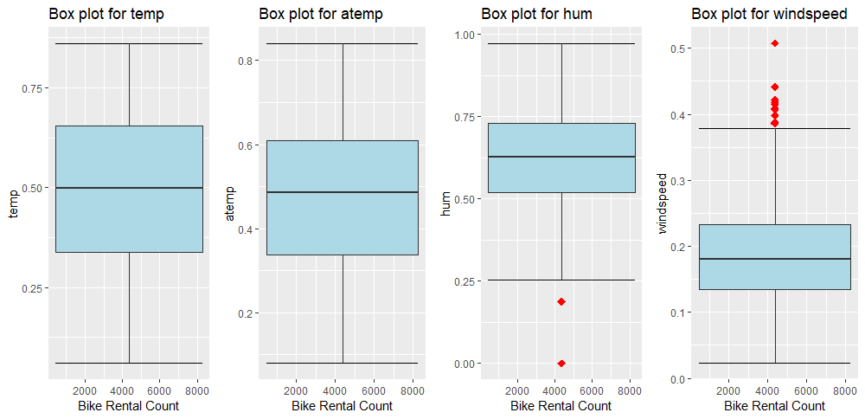

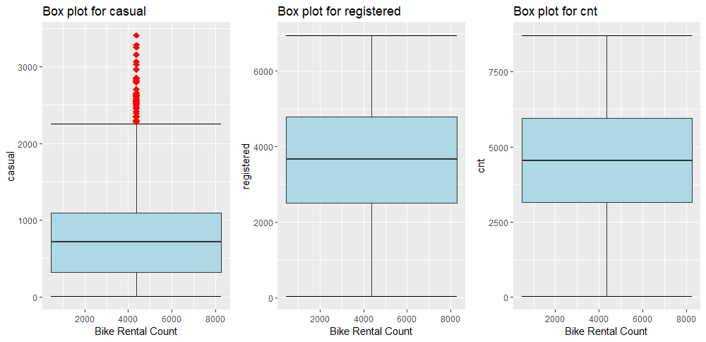

Box plots of the variables after Outlier removal:

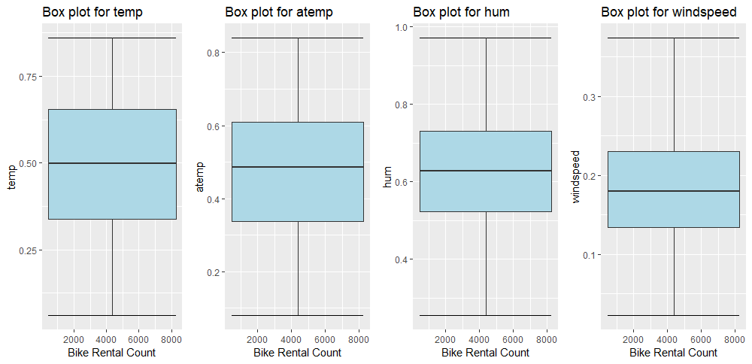

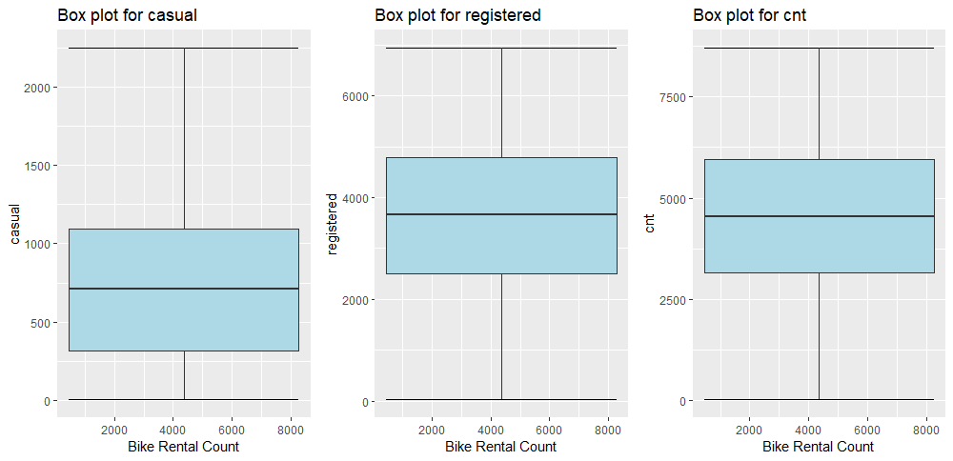

2.1.6. Feature Selection:

It is needed that we assess the importance of each predictor variable in our analysis, as there is a possibility that many variables in our analysis are not important at all to predict the ‘cnt’ values.

A. Using Correlation plots:

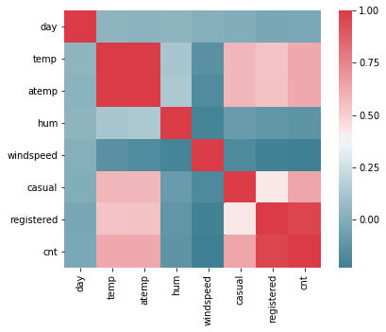

* If |r|>0.8 for two variables, those variables are considered redundant variables and one of them can be removed from the dataset.
* Output: "temp" & "atemp" variables are highly positively correlated as expected after performing the pre-processing of the data.
* Output: "cnt" & "registered" variables are highly positively correlated as expected after performing the pre-processing of the data.

B. Using Chi-square test of Independence (relationship between categorical variables):

(Dependencies amongst Independent Categorical variables)

*#######Chi-square Test of Independence (within Categorical Variables)*

*for(i in catnames){*

*for(j in catnames){*

*if(i!=j){*

*print(names(data[i]))*

*print(paste0(" Vs ", names(data[j])))*

*print(chisq.test(table(data[,j],data[,i])))*

*}}}*

* If p-value<0.05 (Reject Null Hypothesis) => Target variable depends on the independent variable.
* If p-value>0.05 (Do Not Reject Null Hypothesis) =>Target variable & independent variable are independent of each other.
* Output:

*[1] "season"*

*[1] " Vs yr"*

*Pearson's Chi-squared test*

*data: table(data[, j], data[, i])*

*X-squared = 0.0041569, df = 3, p-value = 0.9999*

*[1] "season"*

*[1] " Vs mnth"*

*Pearson's Chi-squared test*

*data: table(data[, j], data[, i])*

*X-squared = 1765.1, df = 33, p-value < 2.2e-16*

*[1] "season"*

*[1] " Vs holiday"*

*Pearson's Chi-squared test*

*data: table(data[, j], data[, i])*

*X-squared = 1.4961, df = 3, p-value = 0.6832*

*.*

*.*

*.*

* "workingday"-"holiday","weekday"-"workingday","weekday"-"holiday" & "mnth"-"season depend on each other significantly.

C. Using Random Forest Algorithm:

*#######Using Random Forest Algorithm:*

*data.rf=randomForest(data$cnt~.,data = data, ntree=1000, keep.forest= F, importance= T)*

*importance(data.rf,type = 1)*

* "holiday" variable has the least importance.

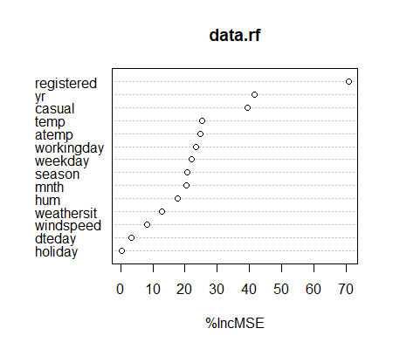

[%IncMSE is the most robust and informative measure. It is the increase in mse of predictions (estimated with out-of-bag-CV) as a result of variable j being permuted (values randomly shuffled).]

D. Using ANOVA test (comparision of Target Vs categorical variables)

*anovacat = aov(cnt ~ season + yr + mnth + holiday + workingday + weekday + weathersit , data = data)*

*summary(anovacat)*

* Df Sum Sq Mean Sq F value Pr(>F)
* season 3 950595868 316865289 436.234 < 2e-16 ***
* yr 1 884008263 884008263 1217.030 < 2e-16 ***
* mnth 11 187311622 17028329 23.443 < 2e-16 ***
* holiday 1 3306975 3306975 4.553 0.03321 *
* workingday 1 3209216 3209216 4.418 0.03591 *
* weekday 5 12629845 2525969 3.478 0.00411 **
* weathersit 2 185659616 92829808 127.800 < 2e-16 ***
* Residuals 706 512813988 726365
* If p-value<0.05 (Reject Null Hypothesis) => Population means are significantly different.
* If p-value>0.05 (Do Not Reject Null Hypothesis) => Population means are not significantly different or are same.

E. Feature Selection

We should remove those features that do not contribute to predicting the target variable as it will only lead to increase in the complexity of the model and reduce interpretability of models.

1. While doing data exploration, we notice that “instant” variable is just a serial number column, so we can remove it.
2. From Chi-square test, we notice that "working day", "holiday" & "weekday" depend on each other and intuitively there is a logical connection within them.

We make a new variable using this connection between the three varibles

[ Denote: 1-->weekend, 2--> working day, 3--> holiday ]

*data$day = NA*

*for (i in 1:nrow(data)){*

*if ((data[i,7]=="0") && (data[i,5]=="0")){data[i,16] = 1} #weekend*

*else if ((data[i,7]=="1") && (data[i,5]=="0")){data[i,16] = 2} #working day*

*else if ((data[i,7]=="0") && (data[i,5]=="1")){data[i,16] = 3} #holiday*

*else data[i,16] =NA }*

1. "Season" has multicollinearity problem as well and it is related to "mnth", so we can remove it.
2. “casual” & “registered” are basically the target variables as their addition results to “cnt”. So, we can remove both & predict for just “cnt” variable.
3. “temp” & “atemp” are highly correlated and “atemp” variable’s importance was found out to be more. Intuitively also, feeling temperature matters more for customers who will be travelling by bikes and hence “temp” variable is redundant.

*data= subset(data, select= -c(season,workingday,temp,casual,registered))*

After dimensional reduction, we have 731 observationa x 10 variables in our data set.

2.1.7. Feature Scaling:

The dataset contains features that are highly varying in magnitudes, units and range. Feature Scaling (Normalization/Standardization) is a step of Data Pre-Processing, which is applied to independent variables or features of data. It helps to normalize the data within a particular range and sometimes helps in speeding up the calculations in distance-based algorithms.

However, the continuous variables in the data set was already normalized.

2.1.8. Data Sampling:

The whole dataset is divided into train and test split sets so that there is data from which the model can learn and there is a part of the data set using which we can do unbiased evaluation of the trained model.

Random sampling without replacement is used to split 80% of the data into training set and remaining 20% into test set.

*sample.index = sample(nrow(data), 0.8*nrow(data), replace = F) #80% data -->Train set, 20%--> Test set*

*train = data[sample.index,]*

*test = data[-sample.index,]*

2.2. Modeling

2.2.1. Model Development:

The dataset of year 2011-2012 indicates that this is a supervised learning problem as there is the task of inferring a function or values from the labeled training data. Secondly, the dependent variable “cnt” is of real valued discrete type and therefore our prediction is of a quantity & it is a regression problem. Since we have many input variables, we shall perform a **multivariate regression analysis** on the given dataset.

2.2.2. Decision Tree Algorithm

Decision Trees

[Decision trees can handle both categorical and numerical variables at the same time as features. Every split in a decision tree is based on a feature. If the feature is categorical, the split is done with the elements belonging to a particular class. If the feature is contiuous, the split is done with the elements higher than a threshold. At every split, the decision tree will take the best variable at that moment. This will be done according to an impurity measure with the splitted branches. And the fact that the variable used to do split is categorical or continuous is irrelevant (in fact, decision trees categorize contiuous variables by creating binary regions with the threshold).]

*dt=rpart(cnt~.,data = train,method= "anova")*

*> summary(dt)*

*Call:*

*rpart(formula = cnt ~ ., data = train, method = "anova")*

*n= 584*

*CP nsplit rel error xerror xstd*

*1 0.37445616 0 1.0000000 1.0051616 0.04580505*

*2 0.22311915 1 0.6255438 0.6603832 0.03348656*

*3 0.09060873 2 0.4024247 0.4239814 0.03179904*

*4 0.02962425 3 0.3118160 0.3290237 0.02734505*

*5 0.02934392 4 0.2821917 0.3120647 0.02819117*

*6 0.02895436 5 0.2528478 0.3120647 0.02819117*

*7 0.01189898 6 0.2238934 0.2660670 0.02168208*

*8 0.01131214 7 0.2119945 0.2668795 0.02194647*

*9 0.01000000 8 0.2006823 0.2633306 0.02187781*

*Variable importance*

*atemp mnth yr hum windspeed weathersit weekday*

*34 27 25 8 4 1 1*

*Node number 1: 584 observations, complexity param=0.3744562*

*mean=4565.748, MSE=3745566*

*left son=2 (234 obs) right son=3 (350 obs)*

*Primary splits:*

*atemp < 0.4308565 to the left, improve=0.37445620, (0 missing)*

*yr splits as LR, improve=0.35623910, (0 missing)*

*mnth splits as LLLRRRRRRRLL, improve=0.30009300, (0 missing)*

*weathersit splits as RLL, improve=0.07434951, (0 missing)*

*hum < 0.824394 to the right, improve=0.06695468, (0 missing)*

*Surrogate splits:*

*mnth splits as LLLRRRRRRRLL, agree=0.894, adj=0.735, (0 split)*

*hum < 0.5464585 to the left, agree=0.625, adj=0.064, (0 split)*

*windspeed < 0.06282915 to the left, agree=0.616, adj=0.043, (0 split)*

*dteday < 29.5 to the right, agree=0.601, adj=0.004, (0 split)*

*Node number 2: 234 observations, complexity param=0.09060873*

*mean=3117.359, MSE=2302852*

*left son=4 (126 obs) right son=5 (108 obs)*

*Primary splits:*

*yr splits as LR, improve=0.36780560, (0 missing)*

*atemp < 0.2607295 to the left, improve=0.23258030, (0 missing)*

*mnth splits as LLLRL--R-RRR, improve=0.19311160, (0 missing)*

*hum < 0.678777 to the right, improve=0.06662897, (0 missing)*

*weathersit splits as RLL, improve=0.06151398, (0 missing)*

*Surrogate splits:*

*hum < 0.5725 to the right, agree=0.577, adj=0.083, (0 split)*

*atemp < 0.332973 to the left, agree=0.573, adj=0.074, (0 split)*

*windspeed < 0.1871895 to the right, agree=0.568, adj=0.065, (0 split)*

*mnth splits as LRLRL--R-LRL, agree=0.564, adj=0.056, (0 split)*

*weekday splits as LLLLLRL, agree=0.543, adj=0.009, (0 split)*

*Node number 3: 350 observations, complexity param=0.2231192*

*mean=5534.1, MSE=2369868*

*left son=6 (164 obs) right son=7 (186 obs)*

*Primary splits:*

*yr splits as LR, improve=0.58840310, (0 missing)*

*hum < 0.834375 to the right, improve=0.15010660, (0 missing)*

*weathersit splits as RRL, improve=0.09686697, (0 missing)*

*atemp < 0.5018855 to the left, improve=0.06263038, (0 missing)*

*mnth splits as -LRLRRRRRRLR, improve=0.05588727, (0 missing)*

*Surrogate splits:*

*hum < 0.6947915 to the right, agree=0.580, adj=0.104, (0 split)*

*mnth splits as -RRLRLRRRRLR, agree=0.569, adj=0.079, (0 split)*

*atemp < 0.5296815 to the left, agree=0.549, adj=0.037, (0 split)*

*weekday splits as RLLRRRR, agree=0.546, adj=0.030, (0 split)*

*windspeed < 0.1741335 to the right, agree=0.543, adj=0.024, (0 split)*

*Node number 4: 126 observations, complexity param=0.02962425*

*mean=2265.302, MSE=1057926*

*left son=8 (75 obs) right son=9 (51 obs)*

*Primary splits:*

*mnth splits as LLLLR----RRR, improve=0.48612910, (0 missing)*

*atemp < 0.251738 to the left, improve=0.30669750, (0 missing)*

*windspeed < 0.112571 to the right, improve=0.24712020, (0 missing)*

*hum < 0.86 to the right, improve=0.11724950, (0 missing)*

*weathersit splits as RLL, improve=0.07345125, (0 missing)*

*Surrogate splits:*

*windspeed < 0.120031 to the right, agree=0.746, adj=0.373, (0 split)*

*atemp < 0.298832 to the left, agree=0.714, adj=0.294, (0 split)*

*hum < 0.611667 to the left, agree=0.611, adj=0.039, (0 split)*

*dteday < 22.5 to the left, agree=0.603, adj=0.020, (0 split)*

*day splits as LLR, agree=0.603, adj=0.020, (0 split)*

*Node number 5: 108 observations, complexity param=0.02895436*

*mean=4111.426, MSE=1920095*

*left son=10 (31 obs) right son=11 (77 obs)*

*Primary splits:*

*atemp < 0.279985 to the left, improve=0.30542030, (0 missing)*

*mnth splits as LLLR---R-LRL, improve=0.28345620, (0 missing)*

*hum < 0.697292 to the right, improve=0.16823620, (0 missing)*

*weathersit splits as RLL, improve=0.09756212, (0 missing)*

*weekday splits as LLLRRRL, improve=0.07717721, (0 missing)*

*Surrogate splits:*

*hum < 0.4647915 to the left, agree=0.741, adj=0.097, (0 split)*

*windspeed < 0.349942 to the right, agree=0.731, adj=0.065, (0 split)*

*mnth splits as RRRR---L-RRR, agree=0.722, adj=0.032, (0 split)*

*weathersit splits as RRL, agree=0.722, adj=0.032, (0 split)*

*Node number 6: 164 observations, complexity param=0.01131214*

*mean=4276.524, MSE=648554.7*

*left son=12 (29 obs) right son=13 (135 obs)*

*Primary splits:*

*mnth splits as -LLLRRRRRRLL, improve=0.23264010, (0 missing)*

*hum < 0.849375 to the right, improve=0.23168870, (0 missing)*

*weathersit splits as RLL, improve=0.18122010, (0 missing)*

*atemp < 0.5805125 to the left, improve=0.17080540, (0 missing)*

*windspeed < 0.1265645 to the right, improve=0.07228776, (0 missing)*

*Surrogate splits:*

*atemp < 0.456723 to the left, agree=0.872, adj=0.276, (0 split)*

*windspeed < 0.299444 to the right, agree=0.854, adj=0.172, (0 split)*

*hum < 0.908125 to the right, agree=0.829, adj=0.034, (0 split)*

*Node number 7: 186 observations, complexity param=0.02934392*

*mean=6642.93, MSE=1263643*

*left son=14 (9 obs) right son=15 (177 obs)*

*Primary splits:*

*hum < 0.8322915 to the right, improve=0.27309330, (0 missing)*

*weathersit splits as RLL, improve=0.13018900, (0 missing)*

*atemp < 0.4927355 to the left, improve=0.12328470, (0 missing)*

*mnth splits as -LLLRRRRRR-L, improve=0.07749548, (0 missing)*

*windspeed < 0.287627 to the right, improve=0.06415826, (0 missing)*

*Surrogate splits:*

*weathersit splits as RRL, agree=0.968, adj=0.333, (0 split)*

*windspeed < 0.3526145 to the right, agree=0.957, adj=0.111, (0 split)*

*Node number 8: 75 observations*

*mean=1673.933, MSE=304991.8*

*Node number 9: 51 observations*

*mean=3134.961, MSE=894587.3*

*Node number 10: 31 observations*

*mean=2904.516, MSE=1394240*

*Node number 11: 77 observations, complexity param=0.01189898*

*mean=4597.325, MSE=1309269*

*left son=22 (18 obs) right son=23 (59 obs)*

*Primary splits:*

*hum < 0.700625 to the right, improve=0.25817860, (0 missing)*

*mnth splits as LLLR-----LRL, improve=0.23626120, (0 missing)*

*weathersit splits as RL-, improve=0.15559330, (0 missing)*

*atemp < 0.3134065 to the left, improve=0.08333220, (0 missing)*

*dteday < 19.5 to the right, improve=0.07422147, (0 missing)*

*Surrogate splits:*

*weathersit splits as RL-, agree=0.792, adj=0.111, (0 split)*

*mnth splits as RRRR-----LRR, agree=0.779, adj=0.056, (0 split)*

*Node number 12: 29 observations*

*mean=3438.448, MSE=473523.1*

*Node number 13: 135 observations*

*mean=4456.556, MSE=502863*

*Node number 14: 9 observations*

*mean=4037.778, MSE=2317994*

*Node number 15: 177 observations*

*mean=6775.395, MSE=847392.4*

*Node number 22: 18 observations*

*mean=3544.722, MSE=1303907*

*Node number 23: 59 observations*

*mean=4918.458, MSE=869753.4*

We predict for test set:

predict.dt=predict(dt,test[,-10])

2.2.3. Random Forest Algorithm

[Random forests are an ensemble learning method for classification, regression and other tasks that operates by constructing a multitude of decision trees at training time and outputting the class that is the mode of the classes (classification) or mean prediction (regression) of the individual trees.]

*rf = randomForest(cnt~., train, importance = TRUE, ntree = 500)*

*> summary(rf)*

*Length Class Mode*

*call 5 -none- call*

*type 1 -none- character*

*predicted 584 -none- numeric*

*mse 500 -none- numeric*

*rsq 500 -none- numeric*

*oob.times 584 -none- numeric*

*importance 18 -none- numeric*

*importanceSD 9 -none- numeric*

*localImportance 0 -none- NULL*

*proximity 0 -none- NULL*

*ntree 1 -none- numeric*

*mtry 1 -none- numeric*

*forest 11 -none- list*

*coefs 0 -none- NULL*

*y 584 -none- numeric*

*test 0 -none- NULL*

*inbag 0 -none- NULL*

*terms 3 terms call*

We predict for test set:

*predict.rf <- data.frame(predict(rf, subset(test, select = -c(cnt))))*

2.2.4. Multiple Linear Regression

Multicollinearity is when independent variables in a regression model are correlated. It tries to inflate or resist the variance of different strong regressors in the data. Therefore, we need to do a collinearity check before performing linear regression.

*#creating dummy variables for categorical data*

*factor_new = dummy.data.frame(factor_data, sep = ".") #731 x 27*

*>*

*> #sampling#*

*> df = cbind(factor_new, num_data)*

*> #for (i in 1:ncol(df)) {*

*> # df[,i] = as.numeric(df[,i])*

*> #}*

*> str(df) # 731 X 32*

*'data.frame': 731 obs. of 32 variables:*

*$ yr.0 : int 1 1 1 1 1 1 1 1 1 1 ...*

*$ yr.1 : int 0 0 0 0 0 0 0 0 0 0 ...*

*$ mnth.1 : int 1 1 1 1 1 1 1 1 1 1 ...*

*$ mnth.2 : int 0 0 0 0 0 0 0 0 0 0 ...*

*$ mnth.3 : int 0 0 0 0 0 0 0 0 0 0 ...*

*$ mnth.4 : int 0 0 0 0 0 0 0 0 0 0 ...*

*$ mnth.5 : int 0 0 0 0 0 0 0 0 0 0 ...*

*$ mnth.6 : int 0 0 0 0 0 0 0 0 0 0 ...*

*$ mnth.7 : int 0 0 0 0 0 0 0 0 0 0 ...*

*$ mnth.8 : int 0 0 0 0 0 0 0 0 0 0 ...*

*$ mnth.9 : int 0 0 0 0 0 0 0 0 0 0 ...*

*$ mnth.10 : int 0 0 0 0 0 0 0 0 0 0 ...*

*$ mnth.11 : int 0 0 0 0 0 0 0 0 0 0 ...*

*$ mnth.12 : int 0 0 0 0 0 0 0 0 0 0 ...*

*$ day.1 : int 1 1 0 0 0 0 0 1 1 0 ...*

*$ day.2 : int 0 0 1 1 1 1 1 0 0 1 ...*

*$ day.3 : int 0 0 0 0 0 0 0 0 0 0 ...*

*$ weekday.0 : int 0 1 0 0 0 0 0 0 1 0 ...*

*$ weekday.1 : int 0 0 1 0 0 0 0 0 0 1 ...*

*$ weekday.2 : int 0 0 0 1 0 0 0 0 0 0 ...*

*$ weekday.3 : int 0 0 0 0 1 0 0 0 0 0 ...*

*$ weekday.4 : int 0 0 0 0 0 1 0 0 0 0 ...*

*$ weekday.5 : int 0 0 0 0 0 0 1 0 0 0 ...*

*$ weekday.6 : int 1 0 0 0 0 0 0 1 0 0 ...*

*$ weathersit.1: int 0 0 1 1 1 1 0 0 1 1 ...*

*$ weathersit.2: int 1 1 0 0 0 0 1 1 0 0 ...*

*$ weathersit.3: int 0 0 0 0 0 0 0 0 0 0 ...*

*$ dteday : num 1 2 3 4 5 6 7 8 9 10 ...*

*$ atemp : num 0.364 0.354 0.189 0.212 0.229 ...*

*$ hum : num 0.806 0.696 0.437 0.59 0.437 ...*

*$ windspeed : num 0.16 0.249 0.248 0.16 0.187 ...*

*$ cnt : num 985 801 1349 1562 1600 ...*

*>*

*> set.seed(123)*

*> train_index = sample(1:nrow(df), 0.8*nrow(df))*

*> train.df = df[train_index,] #584 x 32*

*> test.df = df[-train_index,] #147 x 32*

*>*

*> #Check Multicollinearity*

*vif(df[,-32])*

*Variables VIF*

*1 yr.0 Inf*

*2 yr.1 Inf*

*3 mnth.1 Inf*

*4 mnth.2 Inf*

*5 mnth.3 Inf*

*6 mnth.4 Inf*

*7 mnth.5 Inf*

*8 mnth.6 Inf*

*9 mnth.7 Inf*

*10 mnth.8 Inf*

*11 mnth.9 Inf*

*12 mnth.10 Inf*

*13 mnth.11 Inf*

*14 mnth.12 Inf*

*15 day.1 Inf*

*16 day.2 Inf*

*17 day.3 Inf*

*18 weekday.0 Inf*

*19 weekday.1 Inf*

*20 weekday.2 Inf*

*21 weekday.3 Inf*

*22 weekday.4 Inf*

*23 weekday.5 Inf*

*24 weekday.6 Inf*

*25 weathersit.1 Inf*

*26 weathersit.2 Inf*

*27 weathersit.3 Inf*

*28 dteday 1.010204*

*29 atemp 6.049203*

*30 hum 2.294781*

*31 windspeed 1.207595*

*> vifcor(df[,-32], th = 0.8)*

*3 variables from the 31 input variables have collinearity problem:*

*yr.1 weathersit.2 day.2*

*After excluding the collinear variables, the linear correlation coefficients ranges between:*

*min correlation ( windspeed ~ weekday.3 ): -0.0001206042*

*max correlation ( weekday.0 ~ day.1 ): 0.6450846*

*---------- VIFs of the remained variables --------*

*Variables VIF*

*1 yr.0 1.049547*

*2 mnth.1 Inf*

*3 mnth.2 Inf*

*4 mnth.3 Inf*

*5 mnth.4 Inf*

*6 mnth.5 Inf*

*7 mnth.6 Inf*

*8 mnth.7 Inf*

*9 mnth.8 Inf*

*10 mnth.9 Inf*

*11 mnth.10 Inf*

*12 mnth.11 Inf*

*13 mnth.12 Inf*

*14 day.1 Inf*

*15 day.3 1.106961*

*16 weekday.0 Inf*

*17 weekday.1 Inf*

*18 weekday.2 Inf*

*19 weekday.3 Inf*

*20 weekday.4 Inf*

*21 weekday.5 Inf*

*22 weekday.6 Inf*

*23 weathersit.1 1.779943*

*24 weathersit.3 1.222714*

*25 dteday 1.010204*

*26 atemp 6.049203*

*27 hum 2.294781*

*28 windspeed 1.207595*

*> #Output:*

*> #3 variables from the 31 input variables have collinearity problem: yr.1, weathersit.2, day.2*

*> #removing multicollinear variables and redo check:*

*> df = subset(df, select= -c(yr.1, weathersit.2, day.2))*

*> train.df = subset(train.df, select= -c(yr.1, weathersit.2, day.2)) #584 x 29*

*> test.df = subset(test.df, select= -c(yr.1, weathersit.2, day.2)) #147 x 29*

*> dim(df) #731 x 29*

*[1] 731 29*

*> #Recheck VIFCORR: No variable from the 29 input variables has collinearity problem.*

*>*

*> #run regression model*

*> lr = lm(cnt~., data = train.df)*

*> #summary of the model*

*> summary(lr)*

*Call:*

*lm(formula = cnt ~ ., data = train.df)*

*Residuals:*

*Min 1Q Median 3Q Max*

*-3876.2 -387.8 50.8 509.4 2771.2*

*Coefficients: (3 not defined because of singularities)*

*Estimate Std. Error t value Pr(>|t|)*

*(Intercept) 4430.566 344.461 12.862 < 2e-16 \*\*\**

*yr.0 -2113.166 71.121 -29.712 < 2e-16 \*\*\**

*mnth.1 -825.824 175.718 -4.700 3.29e-06 \*\*\**

*mnth.2 -716.510 179.767 -3.986 7.62e-05 \*\*\**

*mnth.3 138.034 174.608 0.791 0.429552*

*mnth.4 632.261 191.820 3.296 0.001043 \*\**

*mnth.5 957.277 209.921 4.560 6.29e-06 \*\*\**

*mnth.6 673.222 240.603 2.798 0.005319 \*\**

*mnth.7 362.334 258.956 1.399 0.162305*

*mnth.8 644.409 241.596 2.667 0.007868 \*\**

*mnth.9 1396.680 213.404 6.545 1.35e-10 \*\*\**

*mnth.10 1391.067 187.618 7.414 4.56e-13 \*\*\**

*mnth.11 785.587 172.682 4.549 6.61e-06 \*\*\**

*mnth.12 NA NA NA NA*

*day.1 8.810 129.991 0.068 0.945990*

*day.3 -813.416 212.812 -3.822 0.000147 \*\*\**

*weekday.0 -424.315 129.802 -3.269 0.001146 \*\**

*weekday.1 -165.593 133.805 -1.238 0.216395*

*weekday.2 -151.960 130.711 -1.163 0.245504*

*weekday.3 -23.876 130.518 -0.183 0.854920*

*weekday.4 -54.480 133.389 -0.408 0.683114*

*weekday.5 NA NA NA NA*

*weekday.6 NA NA NA NA*

*weathersit.1 448.480 95.588 4.692 3.41e-06 \*\*\**

*weathersit.3 -1468.420 232.217 -6.323 5.24e-10 \*\*\**

*dteday -10.119 3.989 -2.537 0.011455 \**

*atemp 4592.019 519.614 8.837 < 2e-16 \*\*\**

*hum -1522.767 365.632 -4.165 3.61e-05 \*\*\**

*windspeed -2629.300 543.404 -4.839 1.69e-06 \*\*\**

*---*

*Signif. codes: 0 ‘***’ 0.001 ‘**’ 0.01 ‘*’ 0.05 ‘.’ 0.1 ‘ ’ 1*

*Residual standard error: 837.3 on 558 degrees of freedom*

*Multiple R-squared: 0.8237, Adjusted R-squared: 0.8158*

*F-statistic: 104.3 on 25 and 558 DF, p-value: < 2.2e-16*

We predict for test set:

*predict.lr= predict(lr, test.df[,-29])*

2.2.5. KNN Implementation

KNN is distance based non-parametric algorithm and it never stores patterns from the training data, but classifies for new test cases based on a similarity measure.

First, we need to check for the best no. of neighbors (k):

*#To check for best k value:*

*model <- train(cnt~., data = train, method = "knn",*

*trControl = trainControl("cv", number = 10),*

*tuneLength = 15)*

*model$bestTune*

*#k = 3, 9*

*plot(model)*

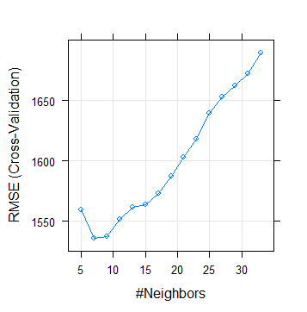

After checking both methods, it is best to choose k=3 as it gives us the least prediction error.

III. Conclusion

3.1 Model Evaluation:

Now that we have a few models for predicting the target variable, we need to decide which one to choose. Several criteria exist for evaluating and comparing models; here we can compare the models by using assessing the ‘Predictive Performance’ of the models. Predictive performance can be measured by comparing Predictions of the models with real values of the target variables, and calculating some average error measure like RMSE or MAPE.

*#Error metric for Decision Tree:*

*postResample(predict.dt,test[,10])*

*#Output:*

*#RMSE Rsquared MAE*

*#1036.8218286 0.7105788 768.8217306*

*#Error metric for Random Forest:*

*postResample(predict.rf,test[,10])*

*#Output:*

*#RMSE Rsquared MAE*

*#778.4675527 0.8507608 576.6110231*

*#Error metric for Multiple Linear Regression:*

*postResample(predict.lr,test.df[,29])*

*#Output:*

*#RMSE Rsquared MAE*

*#800.2783046 0.8303233 581.4298996*

*#Error metric for KNN:*

*postResample(predict.knn$pred,test.df[,29])*

*#Output:*

*#RMSE Rsquared MAE*

*#1392.7631351 0.4544424 1110.0045351*

*#calculate MAPE*

*> mape = function(y,yi)*

*+ {mean(abs((y-yi)/y))*100*

*+ }*

*> mape.dt = mape(test[,10],predict.dt) #30.79%*

*> mape.rf = mape(test[,10],predict.rf$predict.rf..subset.test..select....c.cnt...) # 24.9%*

*> mape.lr = mape(test.df[,29],predict.lr) #17.5%*

*> mape.knn = mape(test.df[,29],predict.knn$pred) #38.98%*

> algorithm MAPE_val

1 Decision Tree 30.79662

2 Random Forest 24.98612

3 Linear Regression 17.55068

4 KNN 38.98097

3.2 Final Model Selection:

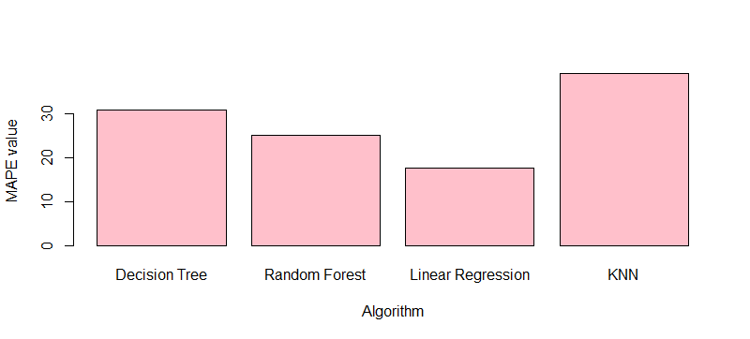

As we can observe that “Multiple Linear Regression” algorithm produces the least error or MAPE (Mean Absolute Percentage Error), we can freeze this algorithm as the model for analysis of new daily data or test cases of Bike Rental count for further years.

Appendix A: Extra plots

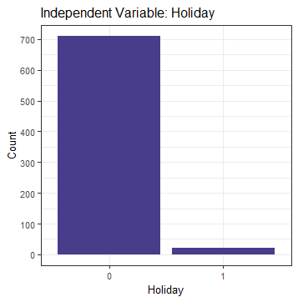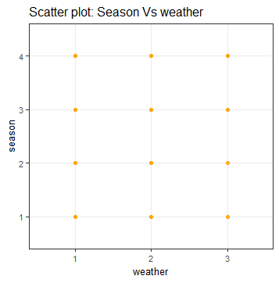

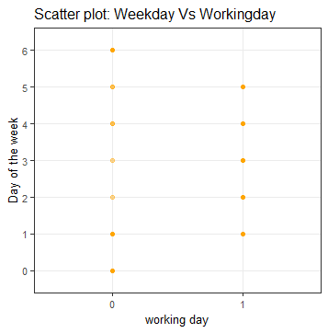

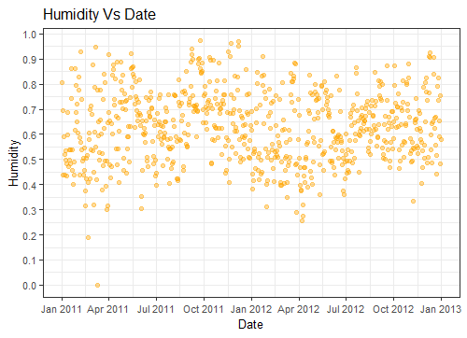

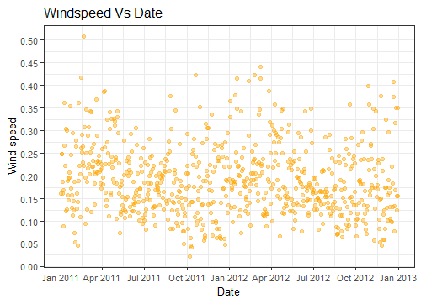

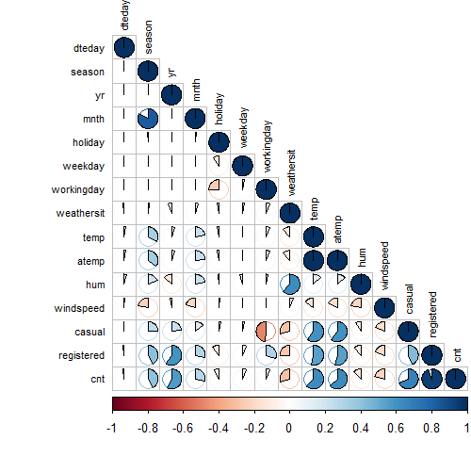

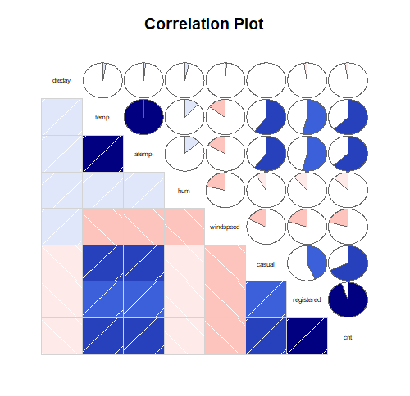

Appendix B: R code

#To clear the R environment of any predefined objects

rm(list=ls())

#To set working directory

setwd("F:/DS/edWisor/Project 2")

getwd()

#To load required libraries

library(ggplot2) # used for ploting

library(dplyr) # used for data manipulation and joining

library(scales) # used for "pretty_brakes() function"

library(DMwR) # used for KNN Imputation

library(outliers) # used for outlier detection & modification

library(corrgram) # used for plotting correlation amongst variables

library(corrplot) # used for plotting correlation amongst variables

library(caret) # used for various model training

library(lubridate) # used for handling date format data

library(FNN) # used for KNN modeling

library(randomForest) # used for Random Forest implementation

library(rpart) # used for Decision Tree algorithm implementation

#To load the data

data = read.csv("day.csv",header = T, na.strings = c(""," ","NA",NA))

####################Data Exploration######################

str(data) #"data.frame"

dim(data) # 731 x 16

###Univariate Analysis###

#col = names(data)

#To find the unique values in each column

#for (i in col) {

# print(i)

# print(length(unique(data[,i])))

#}

#Data has 7 categorical variables, 8 numeric variables & one date type variable.

#Target variable is integer type in nature.

###Data Consolidation###

#Convert into Proper data types

#-->ignoring "instant" as it is just like serial number.

data = data[,-1]

#dim(data) #731 x 15

#_____Data type conversion_____#

catnames = c("season","yr","mnth","holiday","weekday","workingday","weathersit") #categorical variables

for (i in catnames) {

data[,i] = as.factor(data[,i])

}

numnames = c("temp","atemp","hum","windspeed","casual","registered","cnt") #numerical variables

for (i in numnames) {

data[,i] = as.numeric(data[,i])

}

data$dteday = as.Date(data$dteday) #It changed date "02-04-11" to "2011-04-02".

str(data)

###_________________________Graphical analysis_______________________________###

#Histogram for Target variable (continuous variable)

ggplot(data, aes_string(x = data$cnt)) +

geom_histogram(fill="cornsilk", colour = "black") + geom_density() +

scale_y_continuous(breaks=pretty_breaks(n=10)) +

scale_x_continuous(breaks=pretty_breaks(n=10))+

theme_bw() + xlab("Count of total rental bikes") + ylab("Frequency") + ggtitle("Target Variable Histogram") +

theme(text=element_text(size=10))

#Histogram for Independent Continuous Variables

ggplot(data, aes_string(x = data$temp)) +

geom_histogram(fill="blue", colour = "black") + geom_density() +

scale_y_continuous(breaks=pretty_breaks(n=10)) +

scale_x_continuous(breaks=pretty_breaks(n=10))+

theme_bw() + xlab("Normalized Temperature (*C)") + ylab("Frequency") + ggtitle("IndependentVariable:Norm Temperature") +

theme(text=element_text(size=10))

.

.

.

#And so on. The graphs are plotted and recorded in the project report.

###To extract days from "dteday" and make a new variable

data$day = day(data$dteday)

#As we already have information about the year and month, we have the whole date information & can remove the "dteday" date type variable as it may not be suitable for modeling.

data[,1] = data[,16]

data[,16] = NULL #dim = 731 x 15

col = names(data)

##################______________Missing Value Analysis______________##################

sum(is.na(data))

#There are no missing values for this data set.

####################____________Outlier Analysis____________########################

####Box Plot distribution & outlier check####

str(data)

for(i in 1:length(numnames)){

assign(paste0("gn",i), ggplot(aes_string(y = (numnames[i]), x = data$cnt), data = subset(data))+

stat_boxplot(geom = "errorbar", width = 0.5) +

geom_boxplot(outlier.colour="red", fill = "light blue",outlier.shape=18,outlier.size=3, notch=FALSE) +

theme(legend.position="bottom")+

labs(y=numnames[i],x="Bike Rental Count")+

ggtitle(paste("Box plot for",numnames[i])))

}

#Plotting plots together

gridExtra::grid.arrange(gn1,gn2,gn3,gn4,ncol=4)

gridExtra::grid.arrange(gn5,gn6,gn7,ncol=3)

#To check number of outliers in data (ignoring categorical variables, checked earlier)

out = 0.0

for(i in numnames){

val = data[,i][data[,i] %in% boxplot.stats(data[,i])$out]

out = out + length(val)

print(i)

print(length(val))

}

out #= 59. Total Outliers in the data set is 59.

#(59/731)*100 = 8.07% of data.

##To test for the best method to find missing values for this dataset

#data[12,12] #data[12,12] = 0.304627 (actual)

#data[12,12]= NA

#By median method:

#data$windspeed[is.na(data$windspeed)]=median(data$windspeed, na.rm = T)

#data[12,12] #data[12,12] = 0.180971 (median)

#reupload data

#data[12,12] #data[12,12] = 0.304627 (actual)

#data[12,12]= NA

#by mean method:

#data$windspeed[is.na(data$windspeed)]=mean(data$windspeed, na.rm = T)

#data[12,12] #data[12,12] = 0.1903299 (mean)

#reupload data

#data[12,12] #data[12,12] = 0.304627 (actual)

#data[12,12]= NA

#By KNN imputation method:

#(KNN takes only numeric inputs)

#for (i in col) {

# data[,i] = as.numeric(data[,i])

#}

#data= knnImputation(data, k=3) #For k=5,7,9, the difference was even more than k=3.

#data[12,12] #data[12,12] = 0.2324425 (KNN)

#We freeze NA imputation by MEDIAN method as it is closest to actual value.

#reupload data

#Converting outliers to NAs

#Select variables with outliers

Out_Var = c('hum','windspeed','casual') #Variables with outliers

for(i in Out_Var){

val = data[,i][data[,i] %in% boxplot.stats(data[,i])$out]

data[,i][data[,i] %in% val] = NA

}

sum(is.na(data)) #To verify

data= knnImputation(data, k=3)

sum(is.na(data)) #To verify

#Confirm again if any outlier exists

out = 0.0

for(i in numnames){

val = data[,i][data[,i] %in% boxplot.stats(data[,i])$out]

out= out + length(val)

print(i)

print(length(val))

}

out #= 3. Windspeed has 2 outliers & Casual has 1 outlier.

#-->Redo 2 times the imputing using NAs by KNN imputation until 0 outliers.

write.csv(data, 'data_without Outliers.csv', row.names = F)

#To load the data

#data = read.csv("data_without Outliers.csv",header = T)

############################Feature Selection#############################

#Correlation Plot

corrgram(data, order = F,

upper.panel=panel.pie, text.panel=panel.txt, main = "Correlation Plot", font.labels = 1)

#cor(x), x must be numeric

#Convert all columns to numeric type

#for (i in col) {

# data[,i] = as.numeric(data[,i])

#} #NOTE: This changes all zero factor levels to numeric 1. so, "0" --> 1.

#mat = cor(data)

#corrplot(as.matrix(mat),method= 'pie',type = "lower", tl.col = "black", tl.cex = 0.7)

#If |r|>0.8, those two variables are redundant variables.

#Output: "mnth"-"season", "temp"-"atemp" & "cnt"-"registered" are highly positively correlated.

str(data)

#redo data conversion to proper types

catnames = c("season","yr","mnth","holiday","weekday","workingday","weathersit") #categorical variables

for (i in catnames) {

data[,i] = as.factor(data[,i])

}

numnames = c("dteday","temp","atemp","hum","windspeed","casual","registered","cnt") #numerical variables

for (i in numnames) {

data[,i] = as.numeric(data[,i])

}

#######Chi-square Test of Independence (within Categorical Variables)

for(i in catnames){

for(j in catnames){

if(i!=j){

print(names(data[i]))

print(paste0(" Vs ", names(data[j])))

print(chisq.test(table(data[,j],data[,i])))

}

}

}

#If p-value<0.05 (Reject Null Hypothesis) => variable A depends on variable B.

#If p-value>0.05 (Do Not Reject Null Hypothesis) => Variable A & variable B are independent of each other.

#Output: "workingday"-"holiday","weekday"-"workingday","weekday"-"holiday" & "mnth"-"season depend on each other significantly.

#######Using Random Forest Algorithm:

data.rf=randomForest(data$cnt~.,data = data, ntree=1000, keep.forest= F, importance= T)

importance(data.rf,type = 1)

#"holiday" has the least importance.

varImpPlot(data.rf,type = 1)

#######ANOVA test (comparision of Target Vs categorical variables)

anovacat = aov(cnt ~ season + yr + mnth + holiday + workingday + weekday + weathersit , data = data)

summary(anovacat)

#If p-value<0.05 (Reject Null Hypothesis) => Population means are significantly different.

#If p-value>0.05 (Do Not Reject Null Hypothesis) => Population means are not significantly different or are same.

###################___________Feature Engineering____________######################

#From Chi-square test, we notice that "working day", "holiday" & "weekday" depend on each other and intuitively there is a logical connection within them.

#We make a new variable using this connection between the three varibles

#Denote: 1-->weekend, 2--> working day, 3--> holiday

data$day = NA

for (i in 1:nrow(data)){

if ((data[i,7]=="0") && (data[i,5]=="0")){data[i,16] = 1} #weekend

else if ((data[i,7]=="1") && (data[i,5]=="0")){data[i,16] = 2} #working day

else if ((data[i,7]=="0") && (data[i,5]=="1")){data[i,16] = 3} #holiday

else data[i,16] =NA

}

sum(is.na(data$day)) #= 0, so no anomaly data case where it is working day & holiday both.

###################Dimensional Reduction######################

#Won't remove "dteday" variable as the user count is tracked on each day.

#As we added "day" new variable using "workingday" & "holiday", we can remove them both as "day" holds the information of both.

data$holiday = data$day

data$day = NULL

colnames(data)[5] = "day"

data$day = as.factor(data$day) # New variable "day": Factor w/ 3 levels "1","2","3"

#"Season" has multicollinearity problem as well and it is related to "mnth", so we can remove it.

data= subset(data, select= -c(season,workingday,temp,casual,registered))

factor_data = subset(data, select= c(yr,mnth,day,weekday,weathersit)) #5 factor variables

num_data = subset(data, select= c(dteday,atemp,hum,windspeed,cnt)) #5 numerical variables, contains target variable

dim(data) # 731 obs. x 10 variables

str(data)

################################Feature Scaling##################################

#All continuous variables are already normalised in this data set.

rm(list= ls()[!(ls() %in% c('data','factor_data','num_data'))])

##############################Sampling#################################

set.seed(777)

sample.index = sample(nrow(data), 0.8*nrow(data), replace = F) #80% data -->Train set, 20%--> Test set

train = data[sample.index,]

test = data[-sample.index,]

dim(train) # 584 x 11

dim(test) # 147 x 11

##################################Model Development###################################

#As the target variable is of numeric type, this is a regression problem.

######1.Decision Tree######

#Decision trees can handle both categorical and numerical variables at the same time as features.

dt=rpart(cnt~.,data = train,method= "anova")

summary(dt)

#Predict for new test cases

predict.dt=predict(dt,test[,-10])

#Error metric:

postResample(predict.dt,test[,10])

#Output:

#RMSE Rsquared MAE

#1036.8218286 0.7105788 768.8217306

#calculate MAPE

mape = function(y,yi)

{mean(abs((y-yi)/y))*100

}

mape.dt = mape(test[,10],predict.dt) #30.79%

library(mltools)

rmsle(predict.dt,test[,10]) #0.3665

#######2.Random Forest Algorithm#######

rf = randomForest(cnt~., train, importance = TRUE, ntree = 500)

summary(rf)

#Predict for test case:

predict.rf <- data.frame(predict(rf, subset(test, select = -c(cnt))))

#Error metric:

postResample(predict.rf,test[,10])

#Output:

#RMSE Rsquared MAE

#778.4675527 0.8507608 576.6110231

mape.rf = mape(test[,10],predict.rf$predict.rf..subset.test..select....c.cnt...) # 24.9%

########3.Multiple Linear Regression########

#creating dummy variables for categorical data

library(dummies)

factor_new = dummy.data.frame(factor_data, sep = ".") #731 x 27

#sampling#

df = cbind(factor_new, num_data)

#for (i in 1:ncol(df)) {

# df[,i] = as.numeric(df[,i])

#}

str(df) # 731 X 32

set.seed(123)

train_index = sample(1:nrow(df), 0.8*nrow(df))

train.df = df[train_index,] #584 x 32

test.df = df[-train_index,] #147 x 32

#Check Multicollinearity

library(usdm)

vif(df[,-32])

vifcor(df[,-32], th = 0.8)

#Output:

#3 variables from the 31 input variables have collinearity problem: yr.1, weathersit.2, day.2

#removing multicollinear variables and redo check:

df = subset(df, select= -c(yr.1, weathersit.2, day.2))

train.df = subset(train.df, select= -c(yr.1, weathersit.2, day.2)) #584 x 29

test.df = subset(test.df, select= -c(yr.1, weathersit.2, day.2)) #147 x 29

dim(df) #731 x 29

#Recheck VIFCORR: No variable from the 29 input variables has collinearity problem.

#run regression model

lr = lm(cnt~., data = train.df)

#summary of the model

summary(lr)

#Predict for test case:

predict.lr= predict(lr, test.df[,-29])

#Error metric:

postResample(predict.lr,test.df[,29])

#Output:

#RMSE Rsquared MAE

#800.2783046 0.8303233 581.4298996

mape.lr = mape(test.df[,29],predict.lr) #17.5%

##############4.KNN Implementation##############

#To check for best k value:

model <- train(cnt~., data = train, method = "knn",

trControl = trainControl("cv", number = 10),

tuneLength = 15)

model$bestTune

#k = 2 , 7

plot(model)

#K=3:

predict.knn = knn.reg(train = train.df[,-29],test = test.df[,-29],train.df$cnt, k= 3)

print(predict.knn)

#Error metric:

postResample(predict.knn$pred,test.df[,29])

#Output:

#RMSE Rsquared MAE

#1392.7631351 0.4544424 1110.0045351

mape.knn = mape(test.df[,29],predict.knn$pred) #38.98%

#K=5:

#predict.knn = knn.reg(train = train.df[,-29],test = test.df[,-29],train.df$cnt, k= 5)

#print(predict.knn)

#Error metric:

#mape(test.df[,29],predict.knn$pred)

#Output:

#mape

#45.26592 %

#postResample(predict.knn$pred,test.df[,29])

#RMSE Rsquared MAE

#1450.9419952 0.4484269 1169.3782313

#K=7:

#predict.knn = knn.reg(train = train.df[,-29],test = test.df[,-29],train.df$cnt, k= 7)

#print(predict.knn)

#Error metric:

#mape(test.df[,29],predict.knn$pred)

#Output:

#mape

#47.63637 %

#postResample(predict.knn$pred,test.df[,29])

#RMSE Rsquared MAE

#1456.0507716 0.4983456 1171.8736638

######And so on, done upto k = 11.

#A new dataframe to store results

algorithm <- c('Decision Tree','Random Forest','Linear Regression','KNN')

MAPE_val <- c(mape.dt,mape.rf,mape.lr,mape.knn)

results <- data.frame(algorithm, MAPE_val)

print(results)

barplot(results$MAPE_val, width = 1, names.arg = results$algorithm,

ylab="MAPE value", xlab = "Algorithm",col='pink')

##Thus, we find the "Multiple Linear Regression Algorithm" gives us the best result with the least MAPE for this dataset.

Appendix C: Python code

*#Set working directory*

**import** **os**

os.chdir("F:/DS/edWisor/Project 2")

os.getcwd()

**Load libraries**

In [ ]:

**import** **pandas** **as** **pd**

**import** **matplotlib.pyplot** **as** **plt**

**import** **numpy** **as** **np**

**import** **seaborn** **as** **sns**

**from** **sklearn.model_selection** **import** train_test_split

**from** **random** **import** randrange, uniform

**from** **scipy.stats** **import** chi2_contingency

**from** **ggplot** **import** *

In [ ]:

**from** **fancyimpute** **import** KNN

In [ ]:

**import** **datetime** **as** **dt**

In [ ]:

*#Load the data*

data = pd.read_csv("day.csv")

**Data exploration**

In [ ]:

data.shape

In [ ]:

data.head(10)

In [ ]:

type(data)

In [ ]:

data.info()

In [ ]:

*#Missing Value Analysis*

*#Check for missing value*

data.isnull().sum()

*#No missing values in the dataset*

In [ ]:

*#remove "instant" variable as it is just like serial number & doesn't predict*

data = data.drop(['instant'], axis=1)

In [ ]:

data.shape

In [ ]:

*#extracting day number from 'dteday' variable*

data['dteday'].apply(str)

data['dteday'] = pd.to_datetime(data['dteday'])

data['dteday'] = pd.DatetimeIndex(data['dteday']).day

*#removing 'dteday' variable*

In [ ]:

data.head(20)

In [ ]:

*#save numeric & categorical names*

numnames = ["dteday","temp","atemp","hum","windspeed","casual","registered","cnt"]

catnames = ["season","yr","mnth","holiday","weekday","workingday","weathersit"]

data.shape

In [ ]:

**for** i **in** catnames:

data[i] = data[i].astype('object')

**for** i **in** numnames:

data[i] = data[i].astype('float')

In [ ]:

data.dtypes

**Outlier analysis**

In [ ]:

*#Plot boxplot to visualize Outliers*

%**matplotlib** inline

plt.boxplot(data['windspeed'])

In [ ]:

*#Detect and delete outliers from data*

**for** i **in** numnames:

print(i)

q75, q25 = np.percentile(data.loc[:,i], [75 ,25])

iqr = q75 - q25

min = q25 - (iqr*1.5)

max = q75 + (iqr*1.5)

print(min)

print(max)

*#Remove the outliers*

data = data.drop(data[data.loc[:,i] < min].index)

data = data.drop(data[data.loc[:,i] > max].index)

*#data.loc[data[i] < min,:i] = np.nan*

*#data.loc[data[i] > max,:i] = np.nan*

*#Calculate missing value*

*#missing_val = pd.DataFrame(data.isnull().sum())*

*#Impute with KNN*

*#data = pd.DataFrame(KNN(21).fit_transform(data), columns = data.columns)*

In [ ]:

data.shape *#55 rows deleted*

In [ ]:

data.isnull().sum()

**Feature Selection**

In [ ]:

*##Correlation analysis*

*#Correlation plot*

df_corr = data.loc[:,numnames]

*#Set the width and height of the plot*

f, ax = plt.subplots(figsize=(7, 5))

*#Generate correlation matrix*

corr = df_corr.corr()

*#Plot using seaborn library*

sns.heatmap(corr, mask=np.zeros_like(corr, dtype=np.bool), cmap=sns.diverging_palette(220, 10, as_cmap=**True**),

square=**True**, ax=ax)

In [ ]:

*#Chisquare test of independence*

*#loop for chi square values*

**for** i **in** catnames:

print(i)

chi2, p, dof, ex = chi2_contingency(pd.crosstab(data['cnt'], data[i]))

print(p)

In [ ]:

*#New Categorical Variable containing the data of "workingday" & "holiday"*

*#Denote: 1-->weekend, 2--> working day, 3--> holiday*

data.loc[(data['workingday'] == 0) & (data['holiday'] == 0), 'day'] = '1'

data.loc[(data['workingday'] == 1) & (data['holiday'] == 0), 'day'] = '2'

data.loc[(data['workingday'] == 0) & (data['holiday'] == 1), 'day'] = '3'

In [ ]:

data = data.drop(["workingday","holiday","temp","casual","registered"], axis=1)

In [ ]:

data.head(10)

In [ ]:

df = data[['dteday','mnth','yr','season','weekday','day','weathersit','atemp','hum','windspeed','cnt']]

In [ ]:

df.head(10)

In [ ]:

*################################Feature Scaling##################################*

*#All continuous variables are already normalised in this data set.*

numnames = ["dteday","atemp","hum","windspeed"] *#not including "cnt" target variable*

catnames = ["mnth","yr","season","weekday","day","weathersit"]

**Model Development**

In [ ]:

*#Data Sampling*

nrow= len(df.index)

train, test = train_test_split(df, test_size = 0.2)

In [ ]:

train.shape *#540 x 11*

test.shape *#136 x 11*

In [ ]:

*#####Decision Tree Algortithm*

**from** **sklearn.tree** **import** DecisionTreeRegressor

fit_dt= DecisionTreeRegressor(max_depth=2).fit(train.iloc[:,0:10],train.iloc[:,10])

In [ ]:

fit_dt

In [ ]:

predict_dt= fit_dt.predict(test.iloc[:,0:10])

In [ ]:

*#Calculate RMSE*

**def** RMSE(actual, pred):

**return** np.sqrt(((pred - actual) ** 2).mean())

RMSE(test.iloc[:,10],predict_dt)

*#output = 1162.84440171958*

In [ ]:

*######Random Forest Algorithm*

**from** **sklearn.ensemble** **import** RandomForestRegressor

fit_rf = RandomForestRegressor(n_estimators = 100, random_state = 99).fit(train.iloc[:,0:10],train.iloc[:,10])

In [ ]:

fit_rf

In [ ]:

predict_rf= fit_rf.predict(test.iloc[:,0:10])

In [ ]:

RMSE(test.iloc[:,10],predict_rf)

*#output = 765.0407919968172*

In [ ]:

*######Multiple Linear Regression*

**import** **statsmodels.api** **as** **sm**

*#Creat dataframe with all numerical variables*

df.lr = df[['cnt','dteday','atemp','hum','windspeed']]

*#create dummies for categorical variables*

**for** i **in** catnames:

temp = pd.get_dummies(df[i],prefix = i)

df.lr = df.lr.join(temp)

In [ ]:

df.lr.shape *#676 x 36*

In [ ]:

*#split data into train-test sets*

s = np.random.rand(len(df.lr))<0.8

train.lr = df.lr[s] *#80%*

test.lr = df.lr[~s] *#20%*

In [ ]:

train.lr.shape *#564 x 36*

test.lr.shape *#112 x 36*

In [ ]:

*#Build MLR model*

fit_lr = sm.OLS(train.lr.iloc[:,0],train.lr.iloc[:,1:35]).fit()

fit_lr.summary()

In [ ]:

predict_lr = fit_lr.predict(test.lr.iloc[:,1:35])

In [ ]:

RMSE(test.lr.iloc[:,0],predict_lr)

*#output = 713.1957640471251*

In [ ]:

*######KNN Implementation*

**from** **sklearn** **import** neighbors

rmse_val = [] *#to store rmse values for different k*

**for** K **in** range(30):

K = K+1

fit_knn = neighbors.KNeighborsRegressor(n_neighbors = K)

fit_knn.fit(train.iloc[:,0:10], train.iloc[:,10]) *#fit the model*

predict_knn = fit_knn.predict(test.iloc[:,0:10]) *#make prediction on test set*

error = RMSE(test.iloc[:,10] , predict_knn) *#calculate rmse*

rmse_val.append(error) *#store rmse values*

print('RMSE value for k= ' , K , 'is:', error)

In [ ]:

*#plotting the rmse values against k values*

curve = pd.DataFrame(rmse_val)

curve.plot()

*#K=2 is the value of neighbors for least RMSE.*

In [ ]:

*#For K=12:*

fit_knn = neighbors.KNeighborsRegressor(n_neighbors = 2)

fit_knn.fit(train.iloc[:,0:10], train.iloc[:,10]) *#fit the model*

predict_knn = fit_knn.predict(test.iloc[:,0:10]) *#make prediction on test set*

RMSE(test.iloc[:,10] , predict_knn)

*#output = 1209.595772142617*

In [ ]:

*#Thus, we find the "Multiple Linear Regression Algorithm" gives us the best result with the least RMSE for this dataset.*

References

*Mitchell, T. (1997). Machine Learning. McGraw Hill. p. 2*

*Brieman, Friedman, Olshen and Stone, Classification and Regression Trees, 1984*